UPDF FC Catapult Report

Table of Contents
Introduction 2
Methodology 3
Key Concepts and Definitions in Physical Performance Analysis 4
Summary of Player Metrics 6
Player Metric Summary Table 6
Top Players by Metric 6
Players Monitored 7
Match Stats 7
Average Metrics Per Position 8
Average Metrics Per Matchday 9
Comparison Against Season Averages 11
Comparison by Position 12
Percentage of Distance in Speed Zone 13
Club Metrics Plots 14
Speed Zone Percentage by Position Plot 14
Challenges 15
Recommendations 16
Future Plans 17
Appendix: 18

Introduction
In a strategic move to enhance the performance and competitiveness, the Federation of Uganda Football Associations (FUFA) has made a significant investment in modern football technology. Substantial funds have been injected to purchase Catapult equipment, a state-of-the art performance monitoring system for clubs participating in the Uganda Premier League (UPL) and FUFA Women Super League (FWSL). This initiative underscores the Federation’s commitment to elevating the standards of football in Uganda through cutting-edge tools that support player development, match preparation,and overall team performance.
This report summarizes the physical performance outputs of UPDF FC using Catapult tracking data collected during the 2024/25 season. The aim is to provide a clear picture of player workloads, identify trends, and guide future performance strategies. This report presents an overview of player physical performance metrics for UPDF FC captured using the Catapult GPS goal of using Catapult technology is to support evidence-based decision making in areas such as player monitoring, injury management, training load management, and overall performance benchmarking.
By analysing the data collected across the season,this report aims to provide meaningful insights to the technical team and club management, enabling them to track player progress, adjust training programs, and make informed tactical or medical decisions.
It is important to note that the accuracy and completeness of the data depend on consistent device usage, correct session tagging and reliable synchronization procedures across all match days. Variations in data availability due to technical or logistical constraints have been highlighted where relevant.
The report is structured into six key sections to provide a comprehensive overview of player physical performance across the 2024/25 season. The Methodology section explains how the data was collected, cleaned and analysed from all the clubs. The Season Results section presents individual and aggregated performance metrics derived from Catapult data,offering insights into physical output trends such as total distance covered, accelerations made etc. The Club Comparisons section benchmarks performance between clubs within the same league, highlighting variances in player volume and intensity, which may reflect differing technical or fitness strategies. The Challenges section outlines the recurring issues encountered during the season including inconsistent device usage and mislabelled sessions.Building on these insights, the Recommendations section proposes corrective actions such as Refresher training for Catapult operators and improved session standardisation. Finally, the FUFA Future Plans section outlines strategic steps the federation intends to take to enhance data usage, standardise reporting, and promote long term performance monitoring across all top-tier clubs.

Methodology
This report is based on data collected using the Catapult GPS player tracking system during the 2024/25 football season. The data includes performancemetrics such as total distance covered, sprint distance, work ratio, player load, session availability, among others.
Data was collected and uploaded by trained club staff immediately after match sessions. The FUFA Research, Science & Technology (RST) unit oversaw the data collection process, ensuring sessions were split by halves, correctly labelled, and uploaded within 24 hours post-match. Where necessary, additional follow-up was done to correct mislabelled sessions or fill in missing data.
Data cleaning involved removing duplicates, resolving inconsistencies in player-pod assignments, and verifying that each match session met the minimum completeness threshold (e.g., full 90 minutes, minimum number of players tracked). Only match sessions with verified structure and consistent player tracking were included in the analysis.
Performance indicators were aggregated by club and player, then analysed using descriptive statistics and visualized using Microsoft Excel, Power BI, R and Python. Comparisons between clubs were normalized to account for match frequency, number of players per squad, and available data. Clubs with fewer than 10 complete match sessions were excluded from comparative charts to preserve analytical accuracy.
All analyses were performed by the FUFA RST unit using internal data processing workflows. This methodology ensures the reliability and consistency of performance benchmarks used for technical review, club support, and long-term planning.

Key Concepts and Definitions in Physical Performance Analysis
This section introduces the foundational concepts and key metrics commonly used in football physical performance analysis. It provides brief definitions of each term and examples of how these concepts are practically applied within the Ugandan football context. This section is essential for readers- especially club staff, coaches, analysts and administrators – who may be new to physical performance monitoring or are unfamiliar with the technical language used in such reports.

Physical Performance Analysis
A method of collecting and interpreting data related to a player's physical output during training or matches. It helps coaches and performance staff understand workload, monitor fitness, manage fatigue, and prevent injury.

What is Catapult GPS Technology
Catapult is a wearable athlete monitoring system that uses GPS and inertial sensors to capture real-time data on player movement, workload, and intensity. The system includes:
- Wearable Pod: Worn between the players shoulder blades.
- Software Dashboard: Used to upload, process, visualize and download session data.
Catapult Metrics and Their Meaning
Metric | Definition | Unit
Total Distance | The total number of kilometres a player covers while walking or running in a session. | Kilometres(km)
Sprint Distance | Distance covered while running above a set speed threshold of 25.2 km/h. | Metres(m)
Player Load | Measures the total load on a player’s body in a session or game.
Top Speed | The maximum speed (km/h) a player reaches in a session. | Kilometres per Hour (km/h)
Impacts | The number of high-force events (e.g., collisions, landings, tackles | Count
Power Plays | The number of intense actions a player was involved in | Count
Distance per Minute | Intensity measure showing meters covered every minute. | Metres per Minute (m/min)
Work Ratio | Ratio of high-intensity work time to total time | Percentage
Max Acceleration/Deceleration | Peak rate of speed change | Metres per second per second (m/s/s)
Power Score | Measures the power output used per kilogram of your weight. | Watts per Kilogram (w/kg)
Energy | A measure of how much energy is expended during a game or training session. | Kilocalories(kcal)

Importance of These Metrics
These metrics:
- Help identify fatigue or underperformance.
- Allow position-specific benchmarks (e.g., defenders vs. wingers).
- Are used to individualize training.
- Provide objective feedback for performance reviews and recovery protocols.

Speed Zones
There are five speed zones in Catapult. For the 2024/25 season, these were the zones and thresholds that were used.
Zone | Thresholds (km/h) | Intensity | Descriptor
Zone 1 | 0 – 3.6 | Very Low | Standing, Walking at Recovery Pace
Zone 2 | 3.61 – 10.8 | Low to Moderate | Jogging and Easy Runing
Zone 3 | 10.81 – 18 | Moderate to High | Running
Zone 4 | 18.1 – 25.2 | High | High Speed Running
Zone 5 | 25.21 - 43.2 | Maximal | Sprinting

Summary of Player Metrics
Number of Matches Analysed: 29
Number of Matches Uploaded: 29
Percentage of Matches Uploaded: 96.67%

Player Metric Summary Table
Metric | Total | Max | Min | Mean | Std Dev | Range
Distance | 2277.57 | 12.6 | 2.39 | 7.99 | 2.86 | 10.21
Sprint Distance | 230820.35 | 1852.86 | 174.37 | 809.9 | 374.13 | 1678.49
Power Plays | 16080.0 | 117.0 | 12.0 | 56.42 | 24.22 | 105.0
Energy | 274869.73 | 1538.58 | 276.93 | 964.46 | 346.69 | 1261.65
Impacts | 1946.0 | 32.0 | 0.0 | 6.83 | 5.74 | 32.0
Accelerations | 100523.0 | 612.0 | 105.0 | 352.71 | 129.93 | 507.0
Decelerations | 97412.0 | 614.0 | 101.0 | 341.8 | 127.3 | 513.0
Total Actions | 197935.0 | 1226.0 | 210.0 | 694.51 | 256.92 | 1016.0
Player Load | 104197.14 | 563.07 | 122.78 | 365.6 | 113.11 | 440.3
Top Speed | 8457.23 | 34.82 | 23.62 | 29.67 | 2.15 | 11.21
Distance per Minute | 23427.09 | 127.68 | 23.87 | 82.2 | 29.54 | 103.81
Power Score | 3744.27 | 20.49 | 3.84 | 13.14 | 4.79 | 16.65
Work Ratio | 19339.69 | 113.76 | 16.97 | 67.86 | 26.89 | 96.79
Max Acceleration | 1647.16 | 7.91 | 4.45 | 5.78 | 0.56 | 3.46
Max Deceleration | 2042.8 | 10.0 | 4.67 | 7.17 | 0.92 | 5.33
Acceleration Counts per Min | 1033.25 | 6.06 | 1.08 | 3.63 | 1.33 | 4.98
Deceleration Counts per Min | 1001.32 | 6.08 | 1.03 | 3.51 | 1.31 | 5.06

Top Players by Metric
metric | player | value | match day
Distance | Joseph Janjali | 12.5987 | Md26
Sprint Distance | Ocken Emmanuel | 1852.863 | Md25
Power Plays | Ocken Emmanuel | 117.0 | Md25
Energy | Joseph Janjali | 1538.5818 | Md26
Impacts | Christopher Tebandeke | 32.0 | Md16
Accelerations | Joseph Janjali | 612.0 | Md26
Decelerations | Joseph Janjali | 614.0 | Md26
Total Actions | Joseph Janjali | 1226.0 | Md26
Player Load | Joseph Janjali | 563.0742 | Md26
Top Speed | Rashid Faridi | 34.8243 | Md18
Distance per Minute | Joseph Janjali | 127.68188976377952 | Md24
Power Score | Joseph Janjali | 20.4919 | Md24
Work Ratio | Joseph Janjali | 113.7589 | Md24
Acceleration Counts per Min | Joseph Janjali | 6.064409578860446 | Md26
Deceleration Counts per Min | Joseph Janjali | 6.084227910817507 | Md26

Players Monitored
Player Name | Position | Match Days Analysed
Aggrey Kiirya | Defender | 13
Asaph Ssegujja | Midfielder | 4
Bashir Kabuye | Midfielder | 5
Bernard Muwanga | Defender | 22
Christopher Kamagu | Defender | 24
Christopher Tebandeke | Defender | 15
Denis Sekitoleko | Defender | 15
Derrick Jim Ssekulima | Defender | 1
Enrique Lubwama | Midfielder | 6
Frank Gladison Mugisa | Midfielder | 18
Henry Tenywa | Defender | 1
Hussein Hassan Zzinda | Midfielder | 11
Joseph Janjali | Forward | 17
Kakule Swaibu | Defender | 20
Kalumba Brian | Forward | 15
Kawooya Edward | Midfielder | 5
Kitara Daniel | Forward | 2
Ocken Emmanuel | Forward | 13
Rashid Faridi | Forward | 12
Ronald Kayondo | Midfielder | 24
Samson Andrew Kigozi | Forward | 12
Samuel Kayongo Ssekamatte | Forward | 24
Shakibu Mayanja | Forward | 6

Match Stats
Match Day | Opponent Club | Number of Players Monitored | Average Session Duration (min) | Match Result | Match Location
Md1 |  | 0.0 | 0.0
Md2 | Lugazi FC | 9.0 | 101.4 | Win | Home
Md3 | NEC FC | 11.0 | 103.2 | Loss | Away
Md4 | Wakiso Giants FC | 6.0 | 99.5 | Win | Home
Md5 | KCCA FC | 10.0 | 101.9 | Draw | Away
Md6 | Ura FC | 10.0 | 95.9 | Draw | Home
Md7 | SC Villa | 14.0 | 100.4 | Loss | Away
Md8 | Mbarara City FC | 10.0 | 95.0 | Loss | Home
Md9 | Kitara FC | 10.0 | 105.0 | Loss | Away
Md10 | Police FC | 10.0 | 97.6 | Draw | Home
Md11 | Bul FC | 12.0 | 97.4 | Win | Away
Md12 | Mbale Heroes FC | 10.0 | 97.9 | Draw | Home
Md13 | Soltilo Bright Stars FC | 9.0 | 92.2 | Loss | Away
Md14 | Vipers SC | 11.0 | 102.2 | Loss | Home
Md15 | Express FC | 10.0 | 97.2 | Loss | Home
Md16 | Kitara FC | 9.0 | 95.3 | Draw | Home
Md17 | Mbarara City FC | 13.0 | 95.8 | Win | Away
Md18 | SC Villa | 11.0 | 95.9 | Win | Home
Md19 | Ura FC | 8.0 | 97.0 | Loss | Away
Md20 | KCCA FC | 6.0 | 101.9 | Loss | Home
Md21 | Wakiso Giants FC | 10.0 | 96.9 | Win | Away
Md22 | NEC FC | 9.0 | 93.7 | Draw | Home
Md23 | Lugazi FC | 8.0 | 94.2 | Draw | Away
Md24 | Maroons FC | 11.0 | 95.2 | Win | Home
Md25 | Express FC | 11.0 | 99.2 | Draw | Away
Md26 | Vipers SC | 12.0 | 97.6 | Loss | Away
Md27 | Soltilo Bright Stars FC | 10.0 | 92.5 | Win | Home
Md28 | Mbale Heroes FC | 8.0 | 92.1 | Win | Away
Md29 | Police FC | 9.0 | 94.3 | Loss | Away
Md30 | Bul FC | 8.0 | 93.5 | Loss | Home

Average Metrics Per Position
index | 0 | 1 | 2
Position | Defender | Forward | Midfielder
Distance | 8.71 | 6.88 | 8.44
Sprint Distance | 843.8 | 784.33 | 793.72
Power Plays | 57.68 | 51.56 | 61.23
Energy | 1050.12 | 832.18 | 1017.21
Impacts | 8.69 | 5.94 | 5.22
Accelerations | 382.41 | 291.79 | 391.85
Decelerations | 368.94 | 284.91 | 379.23
Total Actions | 751.34 | 576.7 | 771.08
Player Load | 401.06 | 318.91 | 376.29
Top Speed | 30.27 | 30.42 | 27.73
Distance per Minute | 88.97 | 71.31 | 86.98
Power Score | 14.2 | 11.43 | 13.88
Work Ratio | 72.31 | 57.1 | 75.98
Acceleration Counts per Min | 3.9 | 3.02 | 4.04
Deceleration Counts per Min | 3.77 | 2.95 | 3.91

Average Metrics Per Matchday
Match Day | Distance | Sprint Distance | Power Plays | Energy | Impacts | Accelerations | Decelerations | Total Actions | Player Load | Top Speed | Distance per Minute | Power Score | Work Ratio | Acceleration Counts per Min | Deceleration Counts per Min
Md2 | 10.4 | 1156.9 | 75.6 | 1243.6 | 10.3 | 417.0 | 409.2 | 826.2 | 450.7 | 30.9 | 102.3 | 16.3 | 83.8 | 4.1 | 4.0
Md3 | 8.5 | 731.8 | 59.9 | 1037.7 | 8.5 | 420.8 | 410.1 | 830.9 | 407.3 | 29.3 | 82.7 | 13.3 | 68.4 | 4.1 | 4.0
Md4 | 9.2 | 1052.2 | 61.3 | 1114.5 | 8.2 | 379.5 | 375.8 | 755.3 | 397.4 | 30.9 | 92.8 | 14.8 | 70.7 | 3.8 | 3.8
Md5 | 8.1 | 824.2 | 63.4 | 998.8 | 7.3 | 414.2 | 399.4 | 813.6 | 379.0 | 29.2 | 79.8 | 13.0 | 66.9 | 4.1 | 3.9
Md6 | 8.7 | 837.1 | 57.6 | 1032.3 | 10.4 | 345.1 | 339.9 | 685.0 | 378.2 | 30.4 | 90.5 | 14.2 | 74.9 | 3.6 | 3.5
Md7 | 7.3 | 816.0 | 53.1 | 873.1 | 3.9 | 312.7 | 304.1 | 616.9 | 325.5 | 29.6 | 72.4 | 11.6 | 61.0 | 3.1 | 3.0
Md8 | 7.6 | 805.4 | 54.4 | 917.3 | 7.0 | 345.1 | 336.4 | 681.5 | 351.0 | 29.7 | 80.1 | 12.8 | 66.0 | 3.6 | 3.6
Md9 | 7.6 | 669.4 | 48.9 | 904.1 | 5.4 | 321.7 | 308.1 | 629.8 | 339.9 | 28.8 | 72.1 | 11.3 | 58.7 | 3.1 | 2.9
Md10 | 7.9 | 719.0 | 56.1 | 952.5 | 7.7 | 361.0 | 350.2 | 711.2 | 365.1 | 30.0 | 81.4 | 13.0 | 67.9 | 3.7 | 3.6
Md11 | 7.6 | 585.4 | 48.5 | 901.1 | 5.1 | 362.8 | 345.8 | 708.7 | 354.8 | 29.6 | 78.6 | 12.5 | 66.2 | 3.8 | 3.6
Md12 | 8.2 | 939.9 | 60.7 | 981.5 | 6.2 | 353.7 | 334.8 | 688.5 | 377.3 | 30.4 | 84.0 | 13.4 | 68.5 | 3.6 | 3.4
Md13 | 8.1 | 736.2 | 55.9 | 976.1 | 5.6 | 362.1 | 348.3 | 710.4 | 370.5 | 28.7 | 87.8 | 14.1 | 73.6 | 3.9 | 3.8
Md14 | 8.8 | 936.2 | 62.5 | 1048.9 | 8.9 | 381.6 | 369.3 | 750.9 | 397.5 | 31.0 | 85.7 | 13.7 | 70.1 | 3.7 | 3.6
Md15 | 7.0 | 727.5 | 50.5 | 836.5 | 4.3 | 306.4 | 300.8 | 607.2 | 321.2 | 29.6 | 71.6 | 11.4 | 60.0 | 3.2 | 3.1
Md16 | 7.8 | 822.1 | 54.0 | 944.1 | 11.8 | 317.1 | 305.1 | 622.2 | 365.9 | 29.9 | 81.9 | 13.0 | 67.8 | 3.3 | 3.2
Md17 | 7.0 | 762.5 | 48.4 | 850.8 | 6.6 | 305.5 | 298.2 | 603.7 | 338.0 | 29.7 | 73.3 | 11.6 | 59.0 | 3.2 | 3.1
Md18 | 8.3 | 942.2 | 58.6 | 1010.7 | 10.2 | 340.3 | 331.0 | 671.3 | 385.4 | 30.2 | 87.0 | 13.8 | 73.5 | 3.6 | 3.5
Md19 | 6.8 | 598.4 | 43.8 | 827.6 | 4.0 | 317.9 | 310.5 | 628.4 | 330.5 | 28.9 | 70.5 | 11.3 | 57.3 | 3.3 | 3.2
Md20 | 6.5 | 653.3 | 39.7 | 778.0 | 8.0 | 265.3 | 258.2 | 523.5 | 324.1 | 29.5 | 64.0 | 10.1 | 50.1 | 2.6 | 2.5
Md21 | 6.0 | 514.2 | 37.3 | 725.4 | 6.4 | 270.7 | 264.3 | 535.0 | 299.7 | 29.1 | 61.7 | 9.8 | 48.7 | 2.8 | 2.7
Md22 | 7.4 | 796.0 | 53.0 | 892.1 | 6.1 | 307.4 | 290.9 | 598.3 | 332.8 | 29.7 | 78.7 | 12.6 | 64.9 | 3.3 | 3.1
Md23 | 8.8 | 797.5 | 63.9 | 1061.1 | 8.8 | 380.9 | 378.5 | 759.4 | 391.2 | 28.9 | 93.3 | 14.9 | 77.8 | 4.0 | 4.0
Md24 | 8.0 | 810.0 | 52.9 | 955.0 | 6.5 | 334.4 | 326.9 | 661.3 | 355.3 | 29.4 | 83.5 | 13.3 | 70.3 | 3.5 | 3.4
Md25 | 9.6 | 1050.1 | 73.5 | 1161.0 | 4.1 | 443.2 | 423.0 | 866.2 | 419.9 | 29.3 | 96.9 | 15.7 | 81.1 | 4.5 | 4.3
Md26 | 9.0 | 920.9 | 67.2 | 1100.3 | 6.1 | 419.8 | 404.9 | 824.7 | 410.4 | 29.4 | 93.3 | 15.0 | 77.4 | 4.3 | 4.2
Md27 | 7.9 | 919.1 | 60.8 | 958.5 | 6.1 | 329.4 | 318.5 | 647.9 | 350.7 | 29.9 | 85.9 | 13.7 | 69.5 | 3.6 | 3.5
Md28 | 8.2 | 836.6 | 65.1 | 1005.4 | 3.6 | 393.0 | 372.1 | 765.1 | 370.2 | 29.0 | 89.2 | 14.5 | 73.6 | 4.3 | 4.0
Md29 | 7.3 | 648.4 | 48.9 | 882.0 | 6.1 | 342.2 | 327.9 | 670.1 | 344.3 | 29.4 | 77.1 | 12.4 | 62.6 | 3.6 | 3.5
Md30 | 8.4 | 893.4 | 58.1 | 1025.4 | 6.9 | 358.8 | 357.0 | 715.8 | 372.5 | 30.4 | 90.1 | 14.4 | 77.2 | 3.8 | 3.8

Comparison Against Season Averages
index | Club Average | Season Average | % Difference | Position (out of 16)
Distance | 7.99 | 8.51 | -6.11 | 15.0
Sprint Distance | 809.9 | 843.54 | -3.99 | 10.0
Power Plays | 56.42 | 60.22 | -6.31 | 14.0
Energy | 964.46 | 1040.78 | -7.33 | 15.0
Impacts | 6.83 | 6.29 | 8.59 | 7.0
Accelerations | 352.71 | 397.08 | -11.17 | 16.0
Decelerations | 341.8 | 381.1 | -10.31 | 16.0
Total Actions | 694.51 | 778.19 | -10.75 | 16.0
Player Load | 365.6 | 391.02 | -6.5 | 15.0
Top Speed | 29.67 | 29.59 | 0.27 | 7.0
Distance per Minute | 82.2 | 86.75 | -5.24 | 16.0
Power Score | 13.14 | 13.96 | -5.87 | 16.0
Work Ratio | 67.86 | 72.41 | -6.28 | 16.0
Acceleration Counts per Min | 3.63 | 4.05 | -10.37 | 16.0
Deceleration Counts per Min | 3.51 | 3.89 | -9.77 | 16.0

Comparison by Position
Metric | Defender | Forward | Midfielder
Club_distance_km | 8.71 | 6.88 | 8.44
Season_distance_km | 9.03 | 7.56 | 8.66
%Diff_distance_km | -3.59 | -8.98 | -2.6
Club_sprint_distance_m | 843.8 | 784.33 | 793.72
Season_sprint_distance_m | 845.89 | 874.85 | 814.71
%Diff_sprint_distance_m | -0.25 | -10.35 | -2.58
Club_power_plays | 57.68 | 51.56 | 61.23
Season_power_plays | 59.83 | 58.11 | 62.45
%Diff_power_plays | -3.6 | -11.27 | -1.95
Club_energy_kcal | 1050.12 | 832.18 | 1017.21
Season_energy_kcal | 1111.27 | 928.41 | 1050.07
%Diff_energy_kcal | -5.5 | -10.37 | -3.13
Club_impacts | 8.69 | 5.94 | 5.22
Season_impacts | 6.03 | 7.41 | 5.68
%Diff_impacts | 44.06 | -19.79 | -8.1
Club_total_accelerations | 382.41 | 291.79 | 391.85
Season_total_accelerations | 429.52 | 336.12 | 409.06
%Diff_total_accelerations | -10.97 | -13.19 | -4.21
Club_total_decelerations | 368.94 | 284.91 | 379.23
Season_total_decelerations | 412.44 | 323.14 | 391.9
%Diff_total_decelerations | -10.55 | -11.83 | -3.23
Club_total_actions | 751.34 | 576.7 | 771.08
Season_total_actions | 841.96 | 659.25 | 800.96
%Diff_total_actions | -10.76 | -12.52 | -3.73
Club_player_load | 401.06 | 318.91 | 376.29
Season_player_load | 414.91 | 350.11 | 396.52
%Diff_player_load | -3.34 | -8.91 | -5.1
Club_top_speed_kmh | 30.27 | 30.42 | 27.73
Season_top_speed_kmh | 29.83 | 30.55 | 28.5
%Diff_top_speed_kmh | 1.49 | -0.41 | -2.7
Club_distance_per_min_mmin | 88.97 | 71.31 | 86.98
Season_distance_per_min_mmin | 91.91 | 77.38 | 88.39
%Diff_distance_per_min_mmin | -3.2 | -7.86 | -1.59
Club_power_score_wkg | 14.2 | 11.43 | 13.88
Season_power_score_wkg | 14.75 | 12.55 | 14.18
%Diff_power_score_wkg | -3.72 | -8.91 | -2.1
Club_work_ratio | 72.31 | 57.1 | 75.98
Season_work_ratio | 77.06 | 62.0 | 75.51
%Diff_work_ratio | -6.16 | -7.9 | 0.63
Club_max_acceleration_mss | 5.77 | 5.83 | 5.73
Season_max_acceleration_mss | 5.85 | 5.94 | 5.76
%Diff_max_acceleration_mss | -1.48 | -1.97 | -0.54
Club_max_deceleration_mss | 7.49 | 6.98 | 6.94
Season_max_deceleration_mss | 7.15 | 7.31 | 7.04
%Diff_max_deceleration_mss | 4.79 | -4.53 | -1.44
Club_acc_counts_per_min | 3.9 | 3.02 | 4.04
Season_acc_counts_per_min | 4.37 | 3.44 | 4.17
%Diff_acc_counts_per_min | -10.66 | -12.17 | -3.31
Club_dec_counts_per_min | 3.77 | 2.95 | 3.91
Season_dec_counts_per_min | 4.2 | 3.31 | 4.0
%Diff_dec_counts_per_min | -10.23 | -10.8 | -2.34

Percentage of Distance in Speed Zone
index | Zone 1 | Zone 2 | Zone 3 | Zone 4 | Zone 5
Defenders | 11.14 | 51.74 | 27.43 | 8.05 | 1.64
Midfielders | 7.32 | 45.7 | 37.58 | 8.76 | 0.65
Forwards | 9.66 | 47.92 | 31.02 | 9.54 | 1.86

Club Metrics Plots
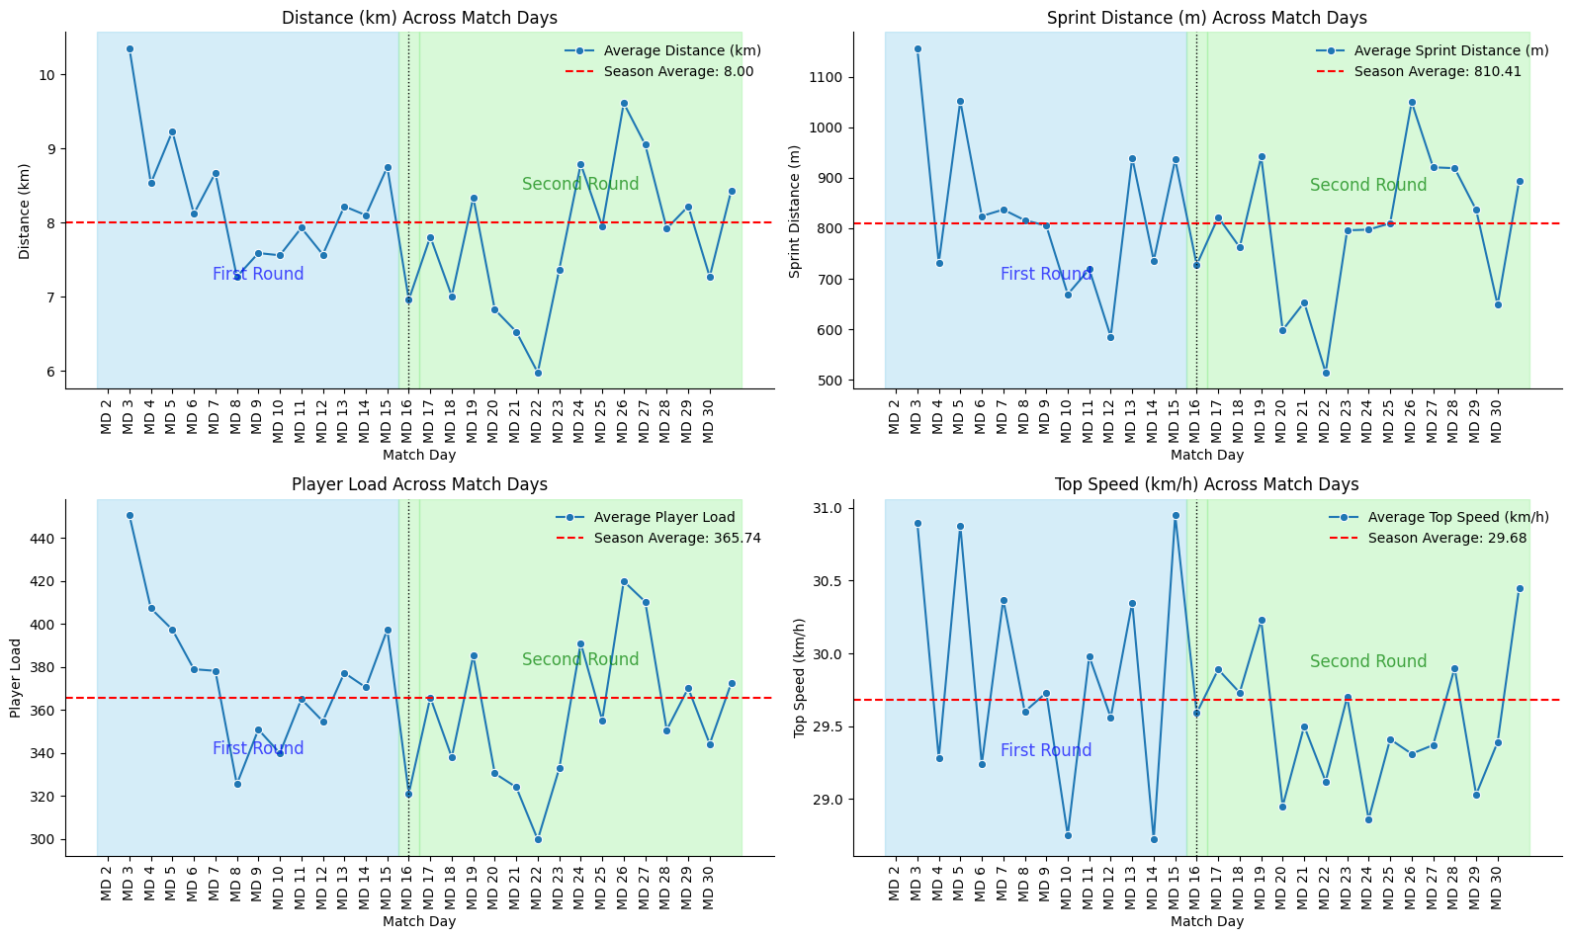

Speed Zone Percentage by Position Plot
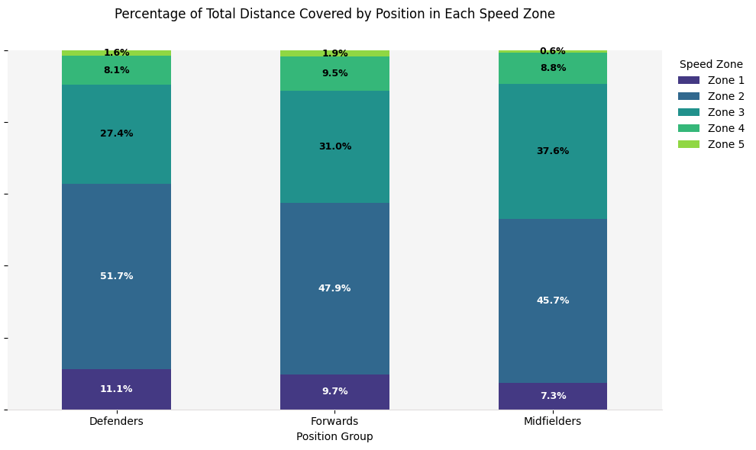

Challenges
Purpose:
Reflect honestly on issues faced in data collection, consistency, or interpretation.
Common challenges:
- Inconsistent use of Catapult devices across games
- Missing data (forgotten devices, battery failure, bad signal)
- Staff not trained on download/upload processes
- Late syncing, causing backlog
- Difficulty aligning performance data with tactical context
Tip: Categorize as:
- Technical (device usage, syncing, etc.)
- Organizational (staff awareness, scheduling)
- Analytical (lack of expertise in data interpretation)

Recommendations
Purpose:
Provide action points backed by data for coaching, conditioning, and club management.
Format: Bullet-pointed or table of:
Area | Recommendation | Justification
Examples:
- Reduce match-to-match variability in sprint distance among midfielders → To ensure consistent high-intensity contribution
- Use sprint and HSR thresholds in training → To better mimic match demands
- Set individual weekly load targets → To reduce overload and underload risk
- Flag players with low total distance but high intensity → Potential fatigue warning

Future Plans
Purpose:
Outline what the club plans to improve based on the season’s findings.
Ideas to include:
- Regular training on Catapult use for staff
- Introducing individual performance benchmarks per position
- Developing return-to-play physical thresholds
- Integrating data with tactical/technical analysis
- Weekly reports or dashboards for the coaching team
- Involving players in performance reviews
📝 Optional: Create a timeline or roadmap here.

Appendix:
- Glossary of terms (HSR, Player Load, etc.)
- Raw data samples
- Charts that didn't fit into the main report

How to Interpret:
- Strengths: Are your players exceeding the league averages? Which metrics stand out?
- Gaps: Are you underperforming in certain metrics despite match success?
- Style Match: Does your data reflect your tactical approach compared to others?
- Outliers: Is one club extremely high or low — and why?

